Pinni Venkata Abhiram

20BAI1132

CSE3002-Internet and Web Programming

Lab – 3

Question – 1

1. Display the images of your choices (gadgets, books, animals) to explore the picture tag. But ensure the caption of the image to be added as per your choice.

HTML Code

<!DOCTYPE html>

<html lang="en">

<head>

    <meta charset="UTF-8">

    <meta http-equiv="X-UA-Compatible" content="IE=edge">

    <meta name="viewport" content="width=device-width, initial-scale=1.0">

    <title>Picture Map</title>

</head>

<body style="margin: 40px; border: solid;">

    <h1 style="text-align: center;"> IPHONE Evolution </h1>

    <hr>

    <figure>

        <picture>

            <source media="(min-width:1500px)" srcset="IphoneX.jfif" width="600" height = "500">

            <source media="(min-width:805px)" srcset="Iphone6.png" width ="600" height="550">

            <img src='Iphone3GS.png' alt='missing'>

        </picture>

        <figcaption style="text-align: center;"><h2>IPHONES Evolution throughout the years</h2></figcaption>

    </figure>

</body>

</html>

Output

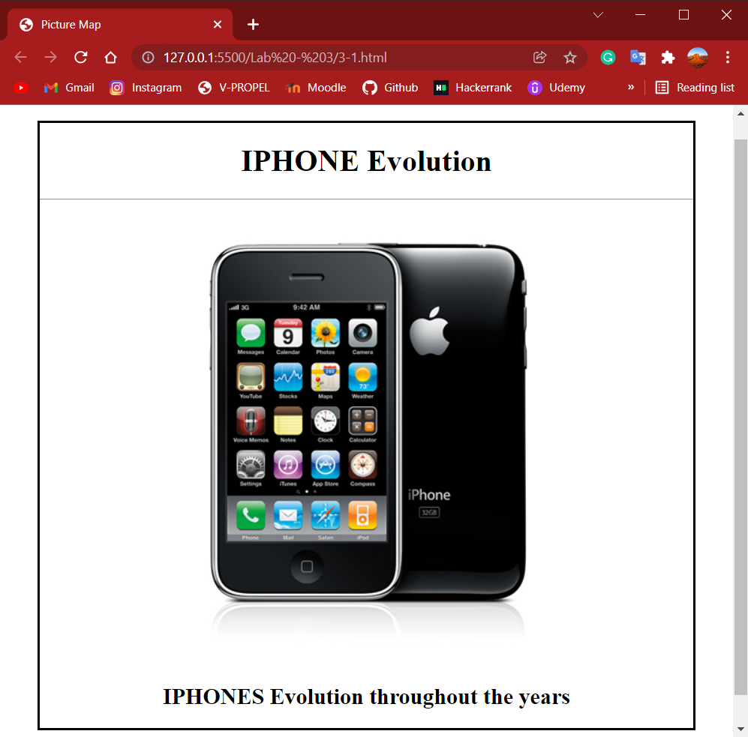

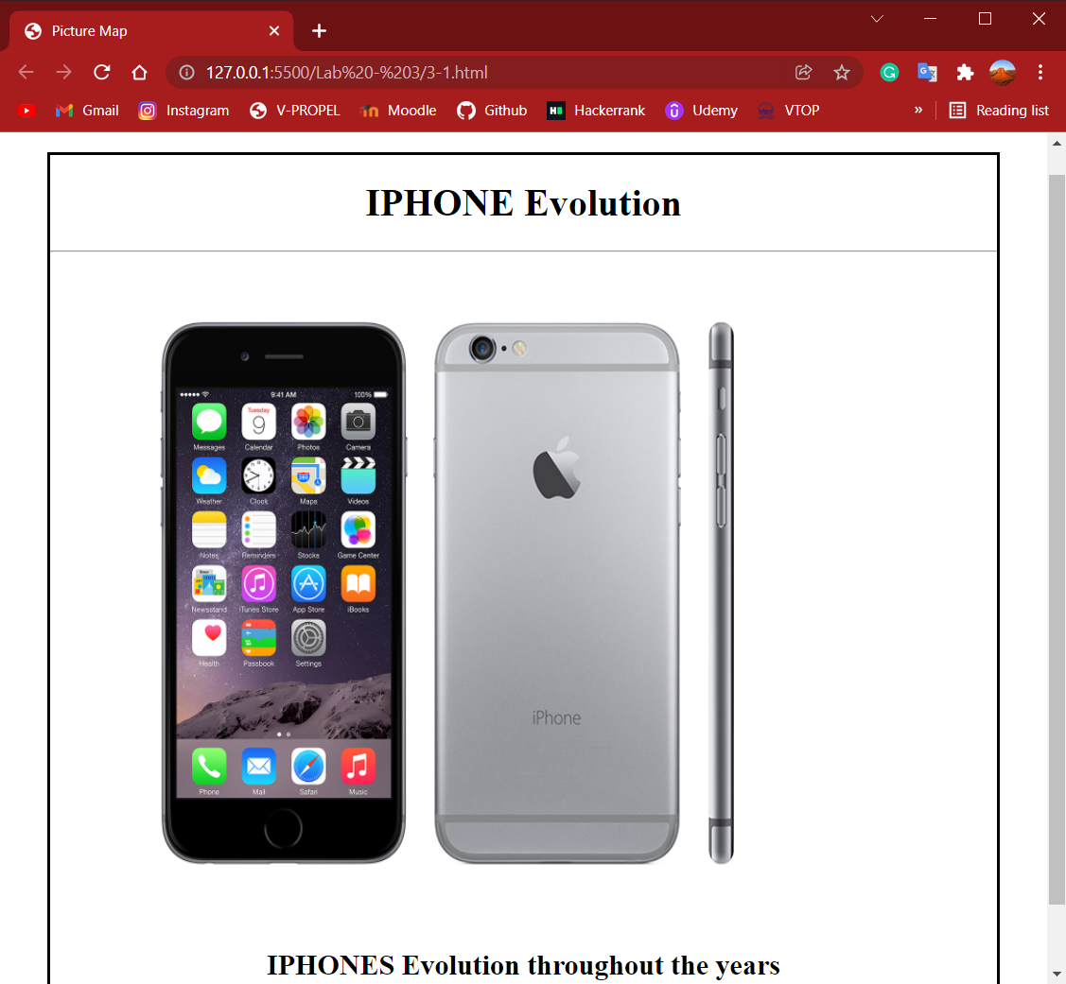

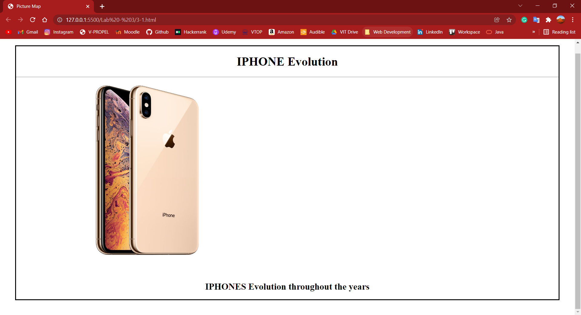

Question – 2

1. Display any 3 states information (state name as a center aligned in green color with capital of the state, functions celebrated in the state and populations of the state as left justified in blue color) of your choice when the user clicks them in our India map.

HTML Code

Main page

<html lang="en">

<head>

    <meta charset="UTF-8">

    <meta http-equiv="X-UA-Compatible" content="IE=edge">

    <meta name="viewport" content="width=device-width, initial-scale=1.0">

    <title>States</title>

</head>

<body style="margin: 40px; border: solid;">

    <h1 style="text-align: center;">India Map </h1>

    <hr>

    <h2 style="text-align: center;">Telangana , Tamil Nadu and Jammu states can be viewed</h2>

    <img src="india-map.jpg" usemap="#states" alt="India" style="margin: 40px;">

    <map name="states">

        <area shape="circle" coords="175,100,30" alt="jammu" href="jammu.html">

        <area shape="circle" coords="250,680,60" alt="Tamil Nadu" href="tamilnadu.html">

        <area shape="circle" coords="250,500,60" href="telangana.html" alt="Telangana">

    </map>

</body>

</html>

Jammu.html code

<!DOCTYPE html>

<html lang="en">

<head>

    <meta charset="UTF-8">

    <meta http-equiv="X-UA-Compatible" content="IE=edge">

    <meta name="viewport" content="width=device-width, initial-scale=1.0">

    <title> Jammu and Kashmir </title>

</head>

<body style="margin: 40px; border: solid;">

     <h1 style="text-align: center; color: green; margin: 20px;">Jammu and Kashmir</h1>

     <hr>

     <h2 style="text-align: center; color: green; margin: 20px;">Captial - Srinagar</h2>

     <hr>

     <h3 style="margin-left: 25px; margin-top: 25px; color: blue;">Festivals Celebrated</h3>

     <p style="margin-left: 25px; margin-top: 25px; color: blue;">

        Some of the main festivals of Kashmir include Lohri, Holi, Navratri, Baisakhi or New Year Day, Guru Ravi Das's Birthday, Tihar and Sankranti.

     </p>

     <hr>

     <h3 style="margin-left: 25px; margin-top: 25px; color: blue;">Population - 1.4 Crores</h3>

</body>

</html>

Tamilnadu.html code

<!DOCTYPE html>

<html lang="en">

<head>

    <meta charset="UTF-8">

    <meta http-equiv="X-UA-Compatible" content="IE=edge">

    <meta name="viewport" content="width=device-width, initial-scale=1.0">

    <title> Tamil Nadu </title>

</head>

<body style="margin: 40px; border: solid;">

     <h1 style="text-align: center; color: green; margin: 20px;">Tamil Nadu</h1>

     <hr>

     <h2 style="text-align: center; color: green; margin: 20px;">Captial - Chennai</h2>

     <hr>

     <h3 style="margin-left: 25px; margin-top: 25px; color: blue;">Festivals Celebrated</h3>

     <p style="margin-left: 25px; margin-top: 25px; color: blue;">

        Pongal.<br>

        Tamil New Year's Day.<br>

        Natyanjali Dance Festival.<br>

        Thaipusam.<br>

        Mahamaham Festival.<br>

        Thiruvaiyaru Festival.<br>

        Karthigai Deepam.

     </p>

     <hr>

     <h3 style="margin-left: 25px; margin-top: 25px; color: blue;">Population - 6.79 Crores</h3>

</body>

</html>

Telangana.html

<!DOCTYPE html>

<html lang="en">

<head>

    <meta charset="UTF-8">

    <meta http-equiv="X-UA-Compatible" content="IE=edge">

    <meta name="viewport" content="width=device-width, initial-scale=1.0">

    <title> Telangana </title>

</head>

<body style="margin: 40px; border: solid;">

     <h1 style="text-align: center; color: green; margin: 20px;">Telangana</h1>

     <hr>

     <h2 style="text-align: center; color: green; margin: 20px;">Captial - Hyderabad</h2>

     <hr>

     <h3 style="margin-left: 25px; margin-top: 25px; color: blue;">Festivals Celebrated</h3>

     <p style="margin-left: 25px; margin-top: 25px; color: blue;">

        The regions major cultural events celebrated are "Kakatiya Festival" and Deccan Festival <br>

        along with religious festivals Bonalu, Bathukamma, Dasara, Ugadi, Sankranthi, Milad un Nabi and Ramadan.<br>

        Telangana State has long been a meeting place for diverse languages and cultures.

     </p>

     <hr>

     <h3 style="margin-left: 25px; margin-top: 25px; color: blue;">Population - 35286757</h3>

</body>

</html>

Output

Main page

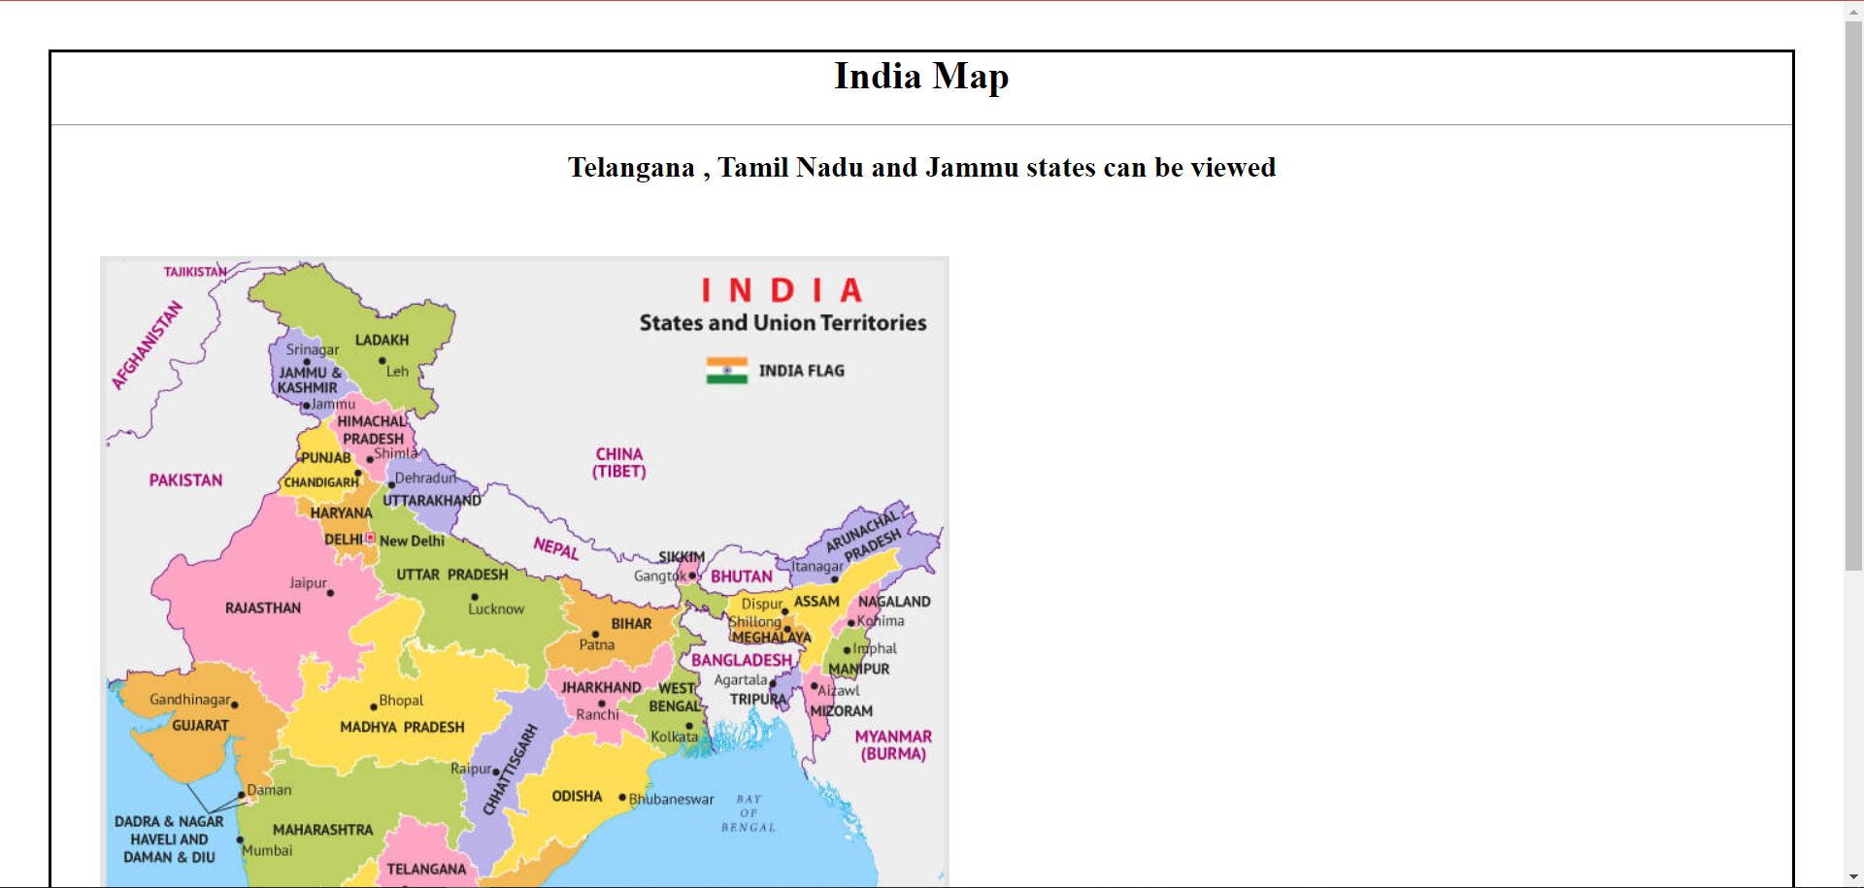

Onclick Jammu and Kashmir state

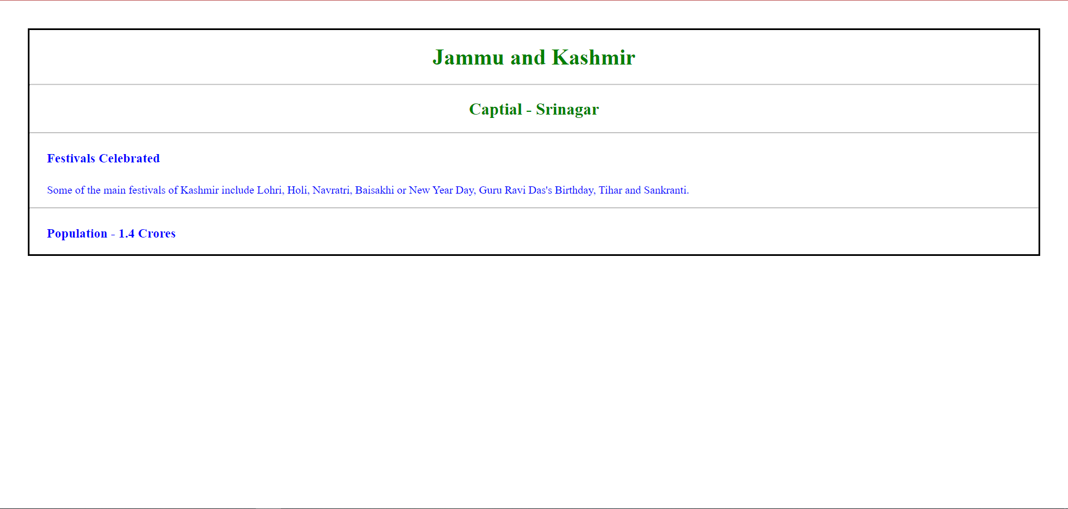

Onclick Telangana State

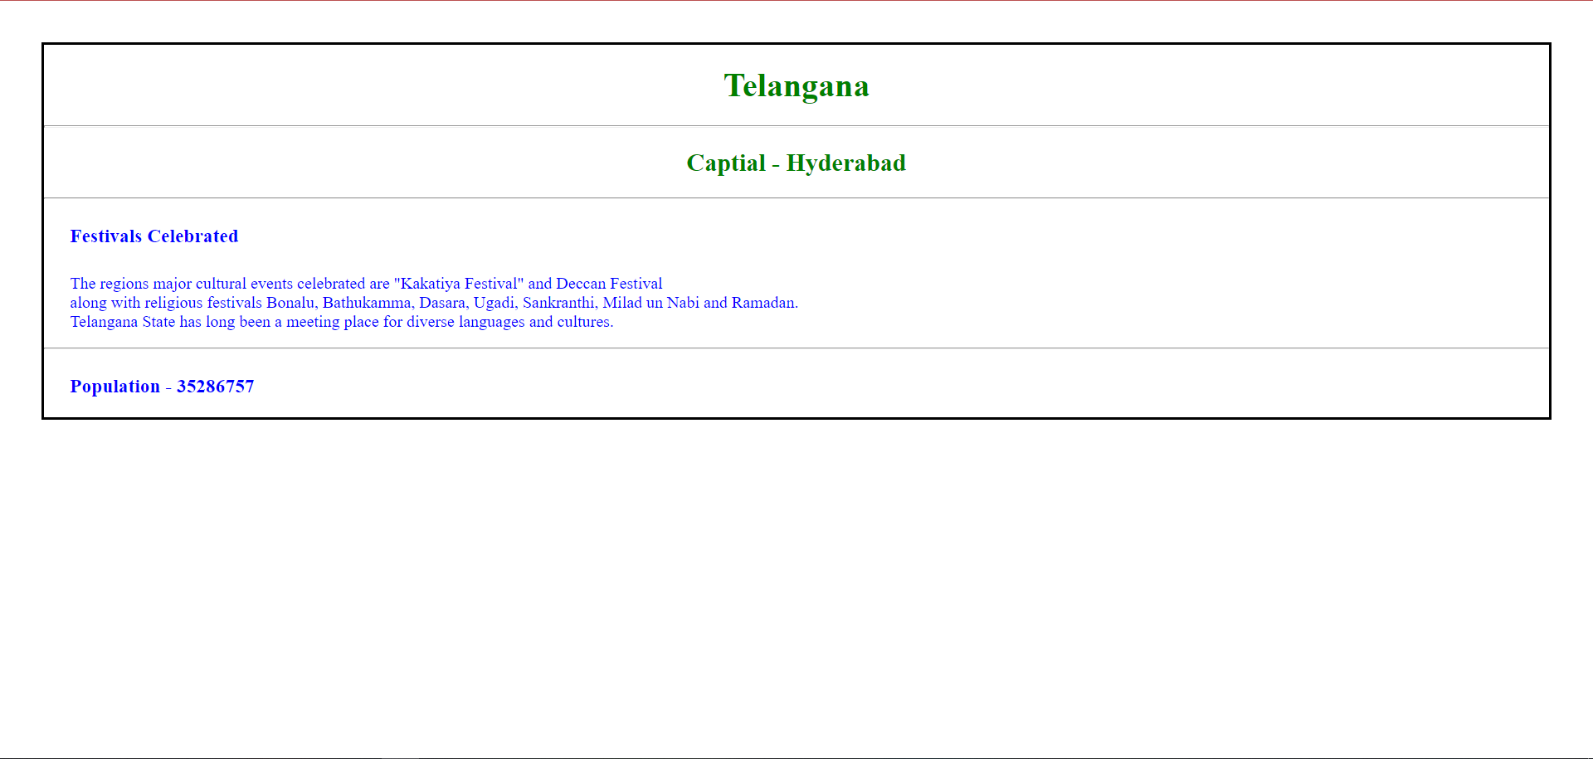

Onclick Tamil Nadu state

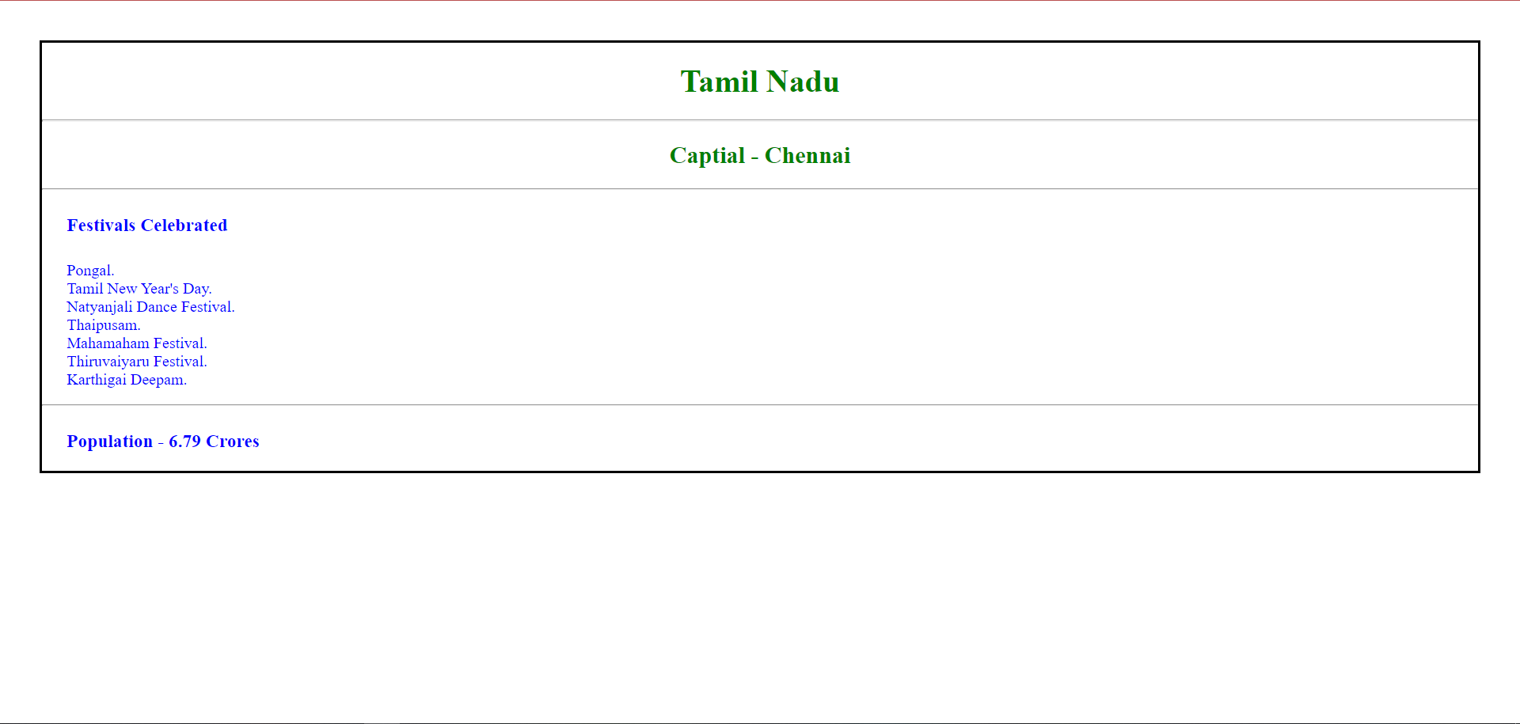

Thank you ma’am

Pinni Venkata Abhiram

20BAI1132